**Name- Neha  
GitHub Assignment**

1. create two files - student.txt and employee.txt and add them to staging area

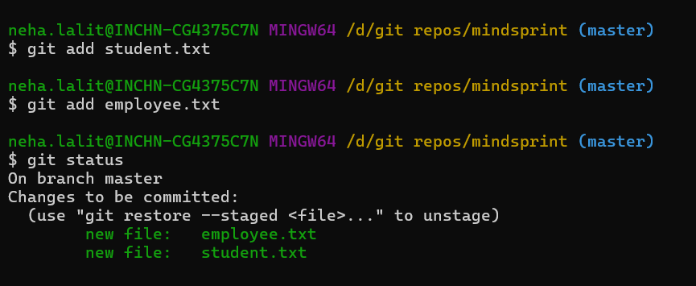

2) add one more file - dept.txt into staging area but at same time restore the employee.txt and modify some changes inside the student.txt

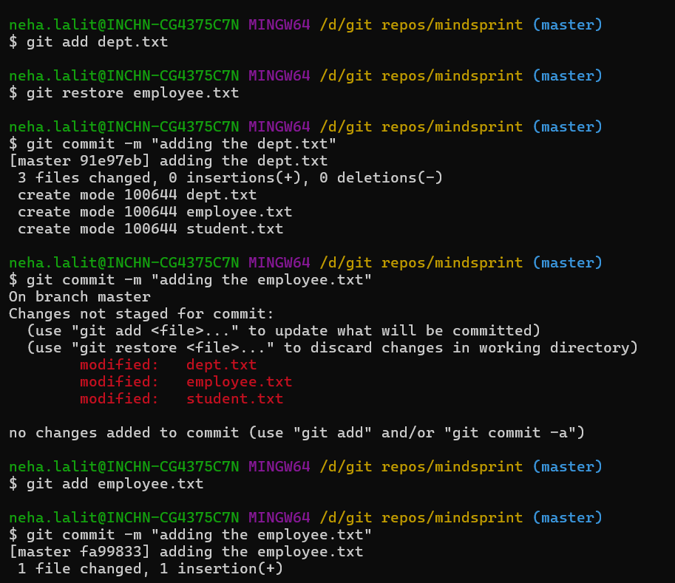

3) push dept.txt and employee.txt to the remote repos

4) create a new file - hello.txt in remote repos directly and bring to the working directory

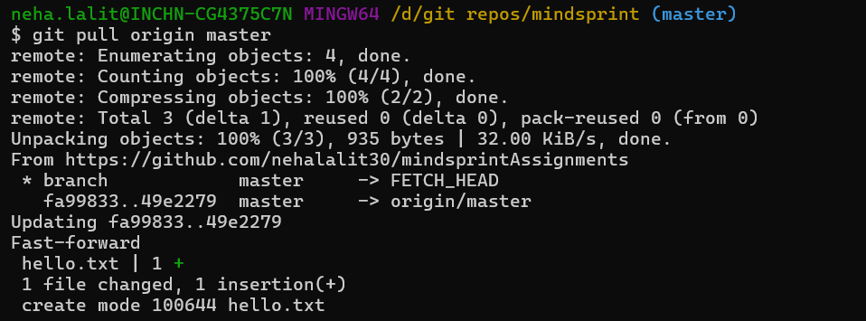  
  
5) remove a file from the remote repos and sync the changes into your working directory

